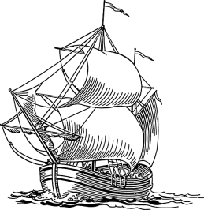
4.1 Roanoke and Jamestown
1. Look at the timeline on “Place and Time.” Copy the first five events in the Americas on the line below:
______________________________________________________________________________

The Mystery of Roanoke
2. What sparked European interest in the Americas?

3. Queen Elizabeth of England gave Sir Walter Raleigh the right to claim land in North America. What happened to the colonies at Roanoke?

Success at Jamestown
4. Define the following terms:
charter
Joint-stock company

5. What was the plan for the Virginia Company? Was that plan successful?

6. How did Captain John Smith contribute to the success of Jamestown?

7. How did the colonists at Jamestown find a way to make money for investors?
8. What caused relations with the Powhatan people to improve?

9. How did the headright system help Jamestown succeed? Use definition of headright in answer.

10. How did the Virginia Company give colonists the right to take part in their own government? Use the definition of burgesses in your answer.

11. What is the significance of the House of Burgesses?

12. Why did Virginia become a royal colony—a colony under control of the English government—in 1624?

4.2 The New England Colonies
Seeking Religious Freedom
1. Define the following terms:
dissent
persecute
tolerance

2. How did the next wave of English settlers differ from the settlers at Jamestown?

3. Describe the Protestant dissenters in England using the following terms: puritans, separatists
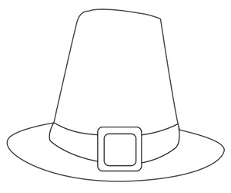
4. List three reasons why the Separatists decided to move to America:

5. What did the Virginia Company permit a group of Separatists to do in 1620?

6. What is a pilgrim?

7. What was the Mayflower Compact and why was there a need for it once the Pilgrims landed in Plymouth?

9. How was the Mayflower Compact a key step in the development of democracy in America?

10. What events led to the first celebration of thanksgiving in the fall of 1621?

New Colonies
1. Describe how the colony of Massachusetts was established.

2. What was the Great Migration?

3. Who was allowed to participate in the government?

4. What was ironic about the way the Puritans governed Massachusetts? Be specific.

This lack of tolerance led people to form new colonies. Answer the questions below:
Connecticut
Founder:

5. What were the Fundamental Orders of Connecticut?

6. How are the Fundamental Orders significant to the development of democracy in America?
Rhode Island
Founder:

7. Name two things he believed:

8. How was Rhode Island different from other colonies in New England?
New Hampshire
Founder:
9. Summarize the causes and effects of King Philip’s War:

